CRACK ME 4

1. Crack it to extend beyond 30 days
2. In the About screen – also extend it to beyond 30 days

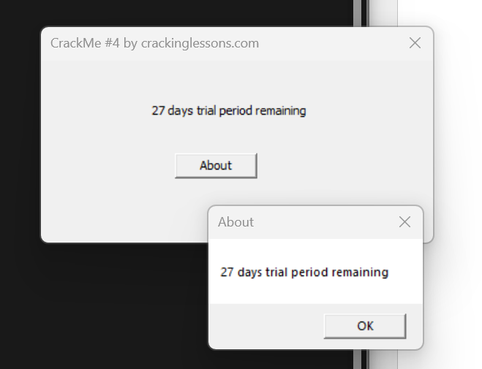

Open CrackMe4.exe in x32dbg to analyze.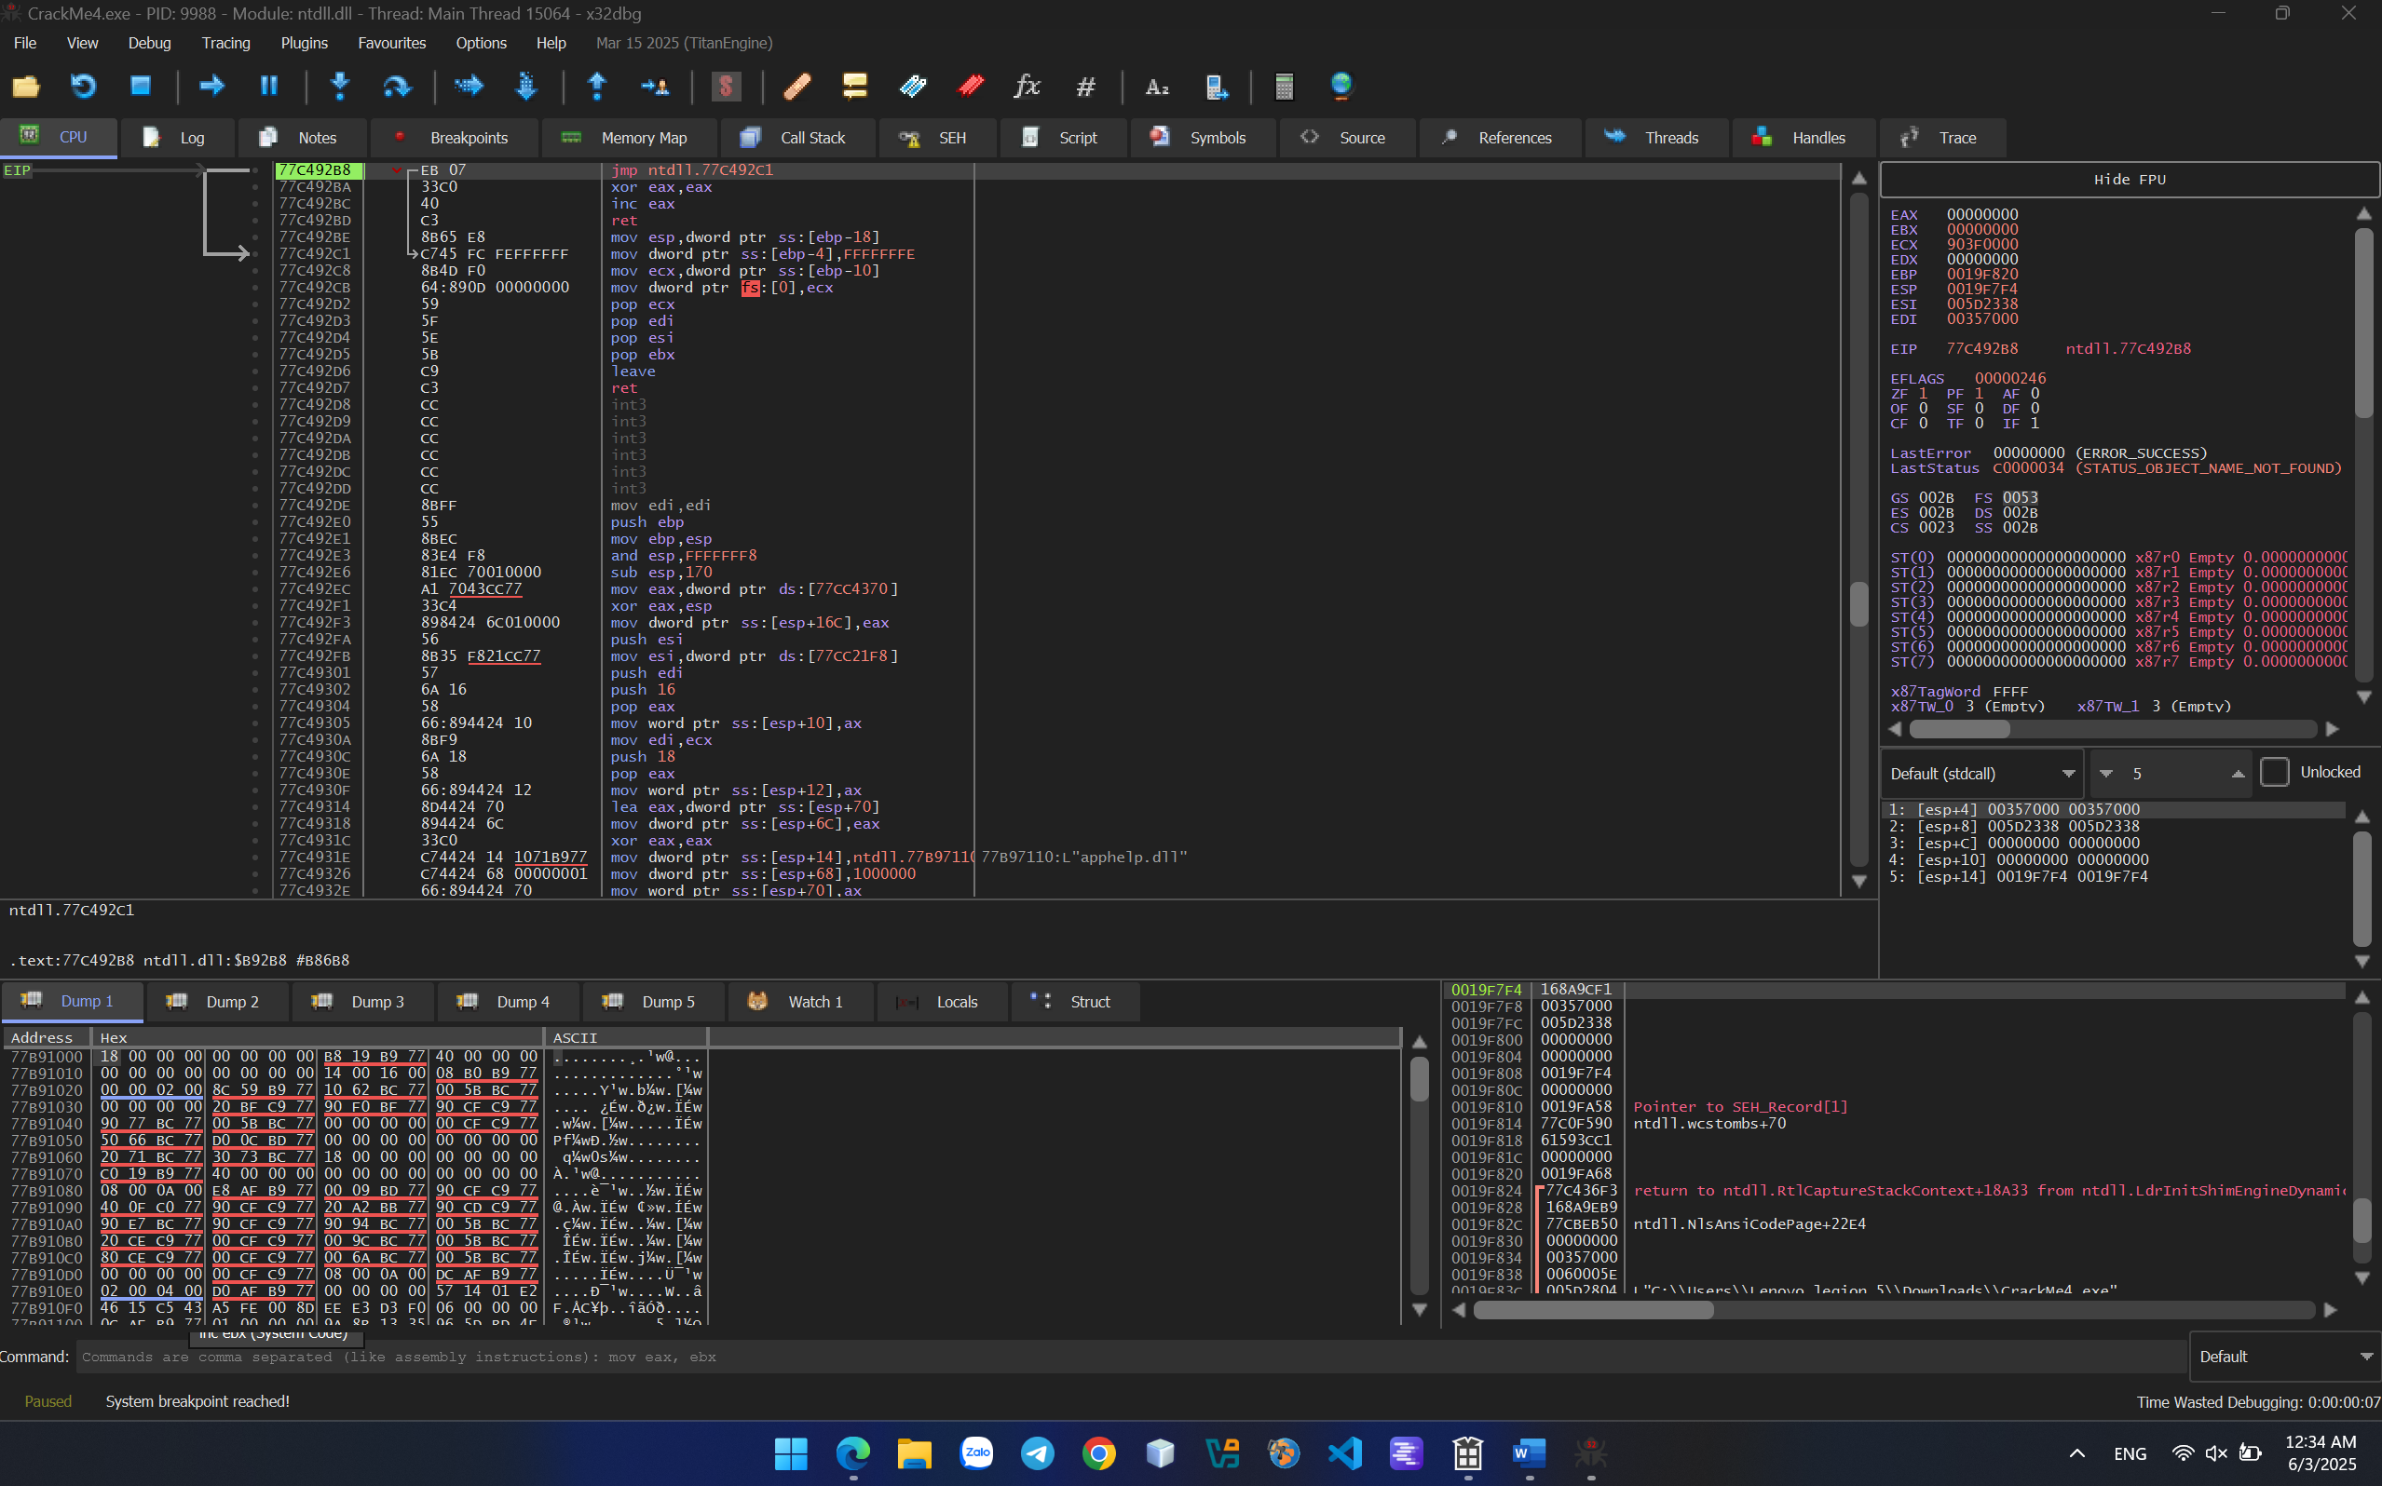

Press F9 to run until the box of “27 days trial period remaining” displays.

Choose Search for > Current Module > typing “27 days trial period remaining” and find related strings. 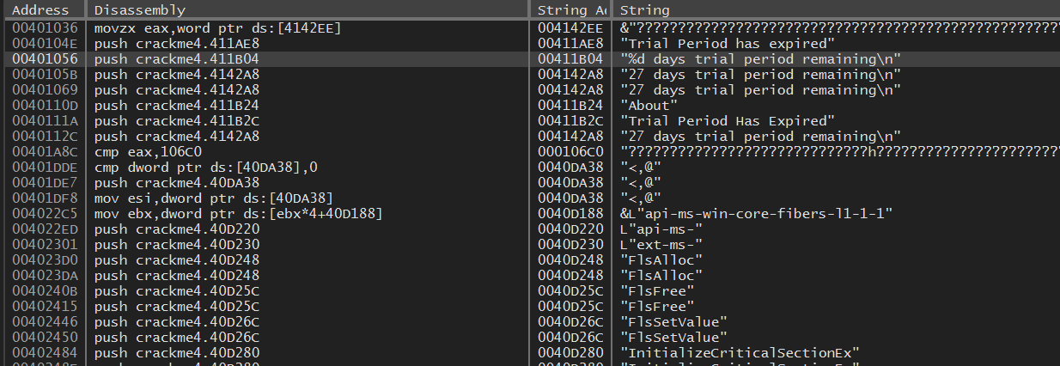

Notice the string "%d days trial period remaining\n" and inspect to the assembly code of these string.

Analyze above and below code of this string.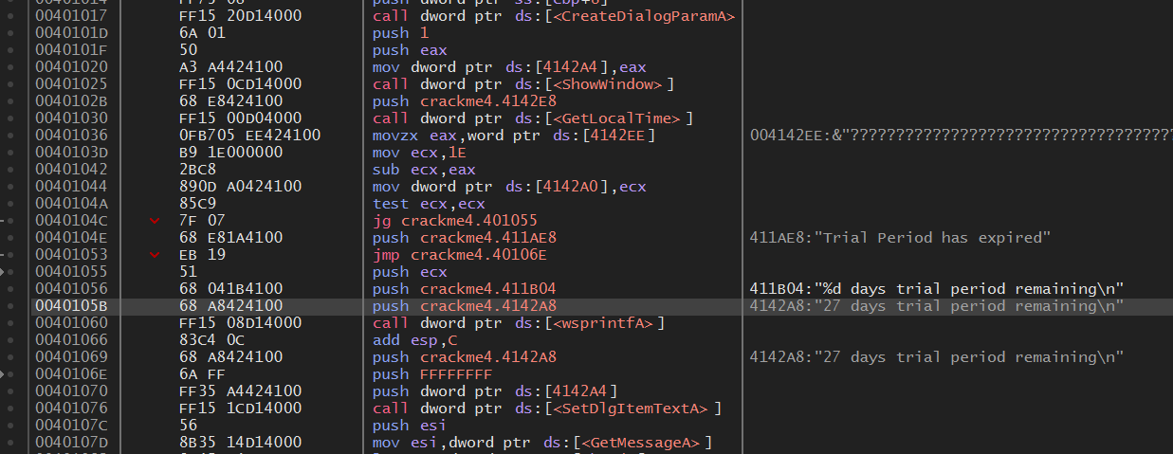

Notice these some line of code. 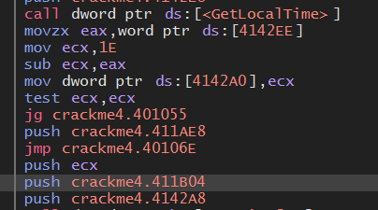

Function GetLocalTime get time of system and move to EAX.

Mov ecx,1E => ECX is assigned 1E (equal decimal 30).

Sub ecx, eax => ecx – eax = 30 – system time(3) = time remaining (27)

It means replacing value in ECX greater than 30(d) to crack extending beyond 30 days.

Decison change it to another value greater than 1E, such 32 (50 in decimal). Patch it and run to check the result.

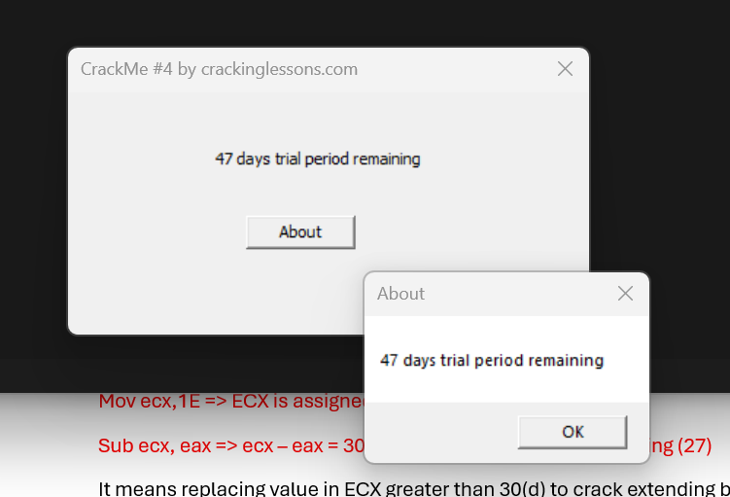

Explain: because the time of doing this lesson is 3rd of June, 2025. Hence, when changing ECX to 50 decimal, we could receive 47 days trial period remaining.

Done!